**DATA BRICKS JOB SCHEDULING, STORAGE ACCOUNT AND DATA LAKE**

**Name: S.Nikhil Sai**

**Date: 2 -12-2024**

**JOB SCHEDUING IN DATA BRICKS:**

**Step 1: Click on create job.**

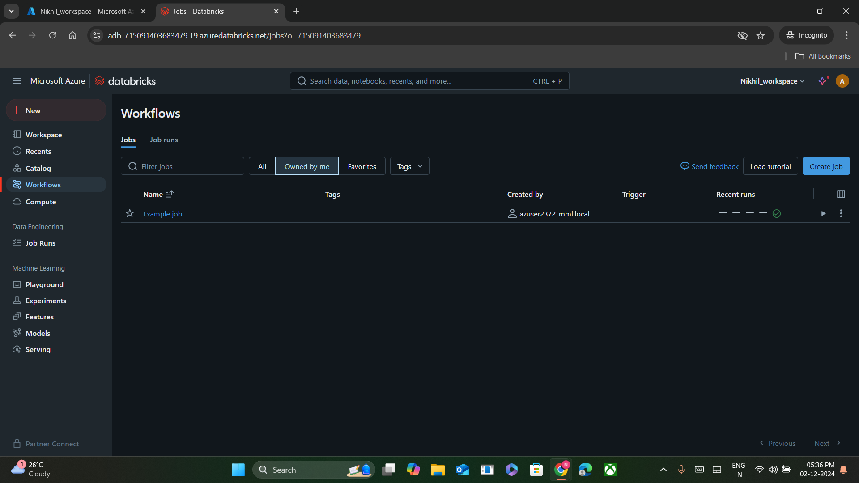

**Step 2: Fill the required details to schedule job.**

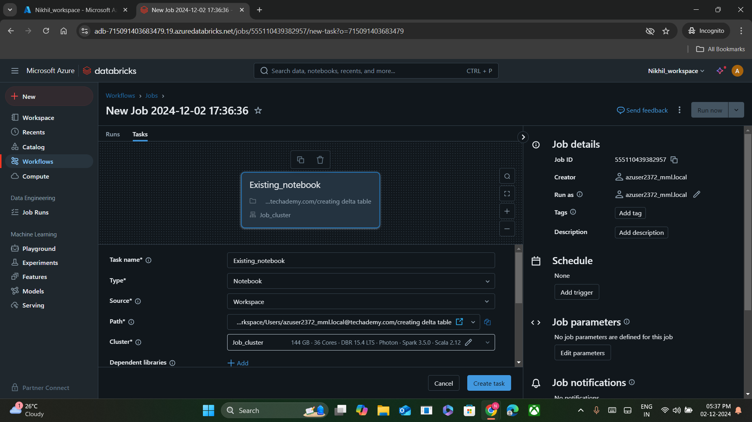

**Step 3: Click on save task**

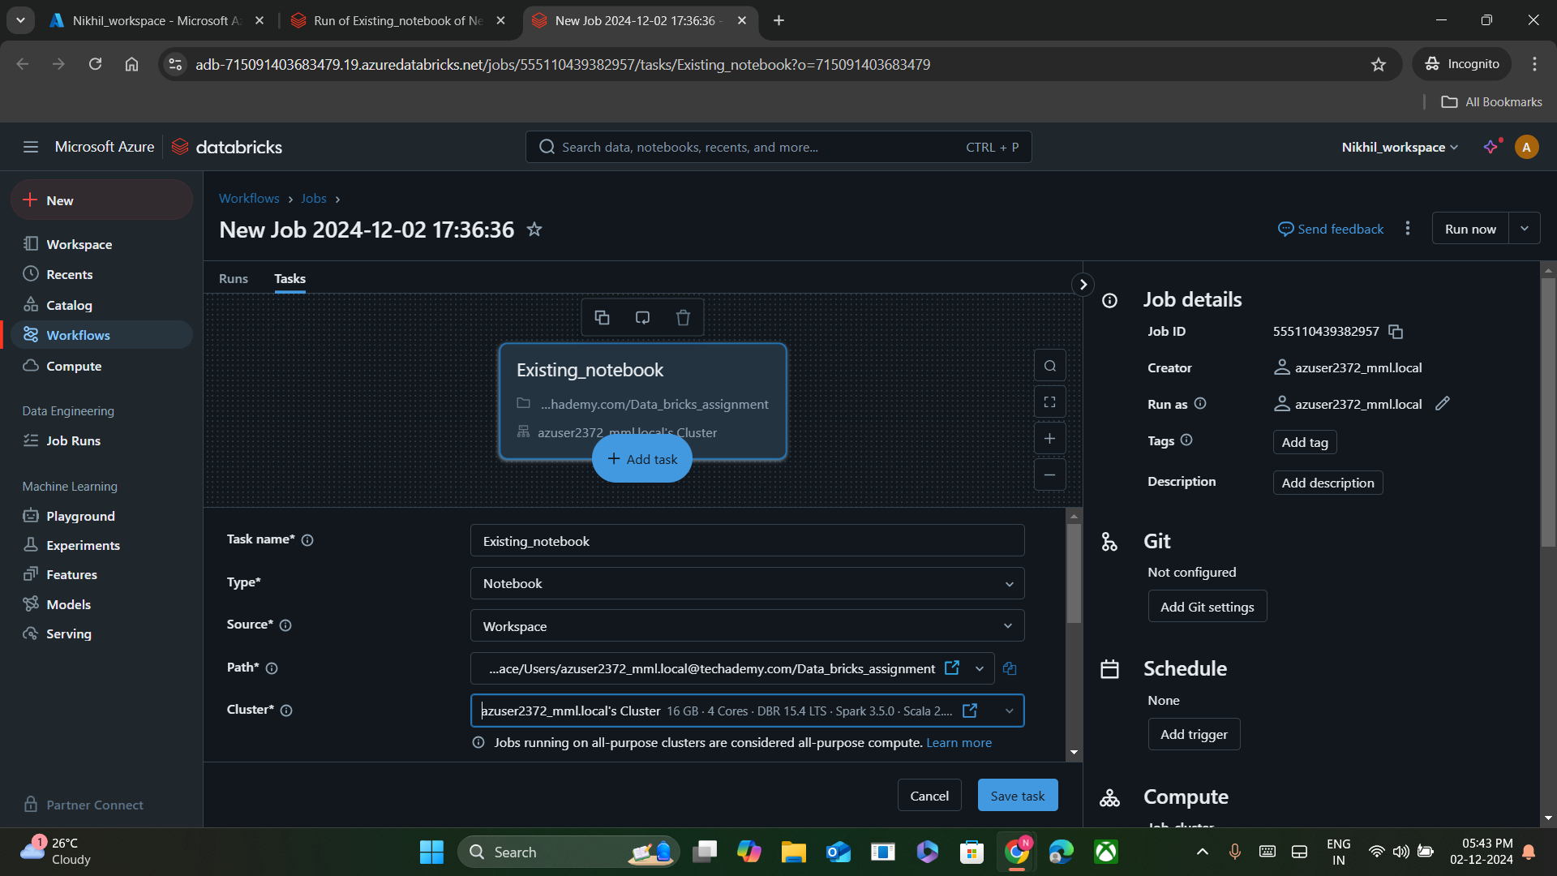

**Step 4: Click on Run Task**

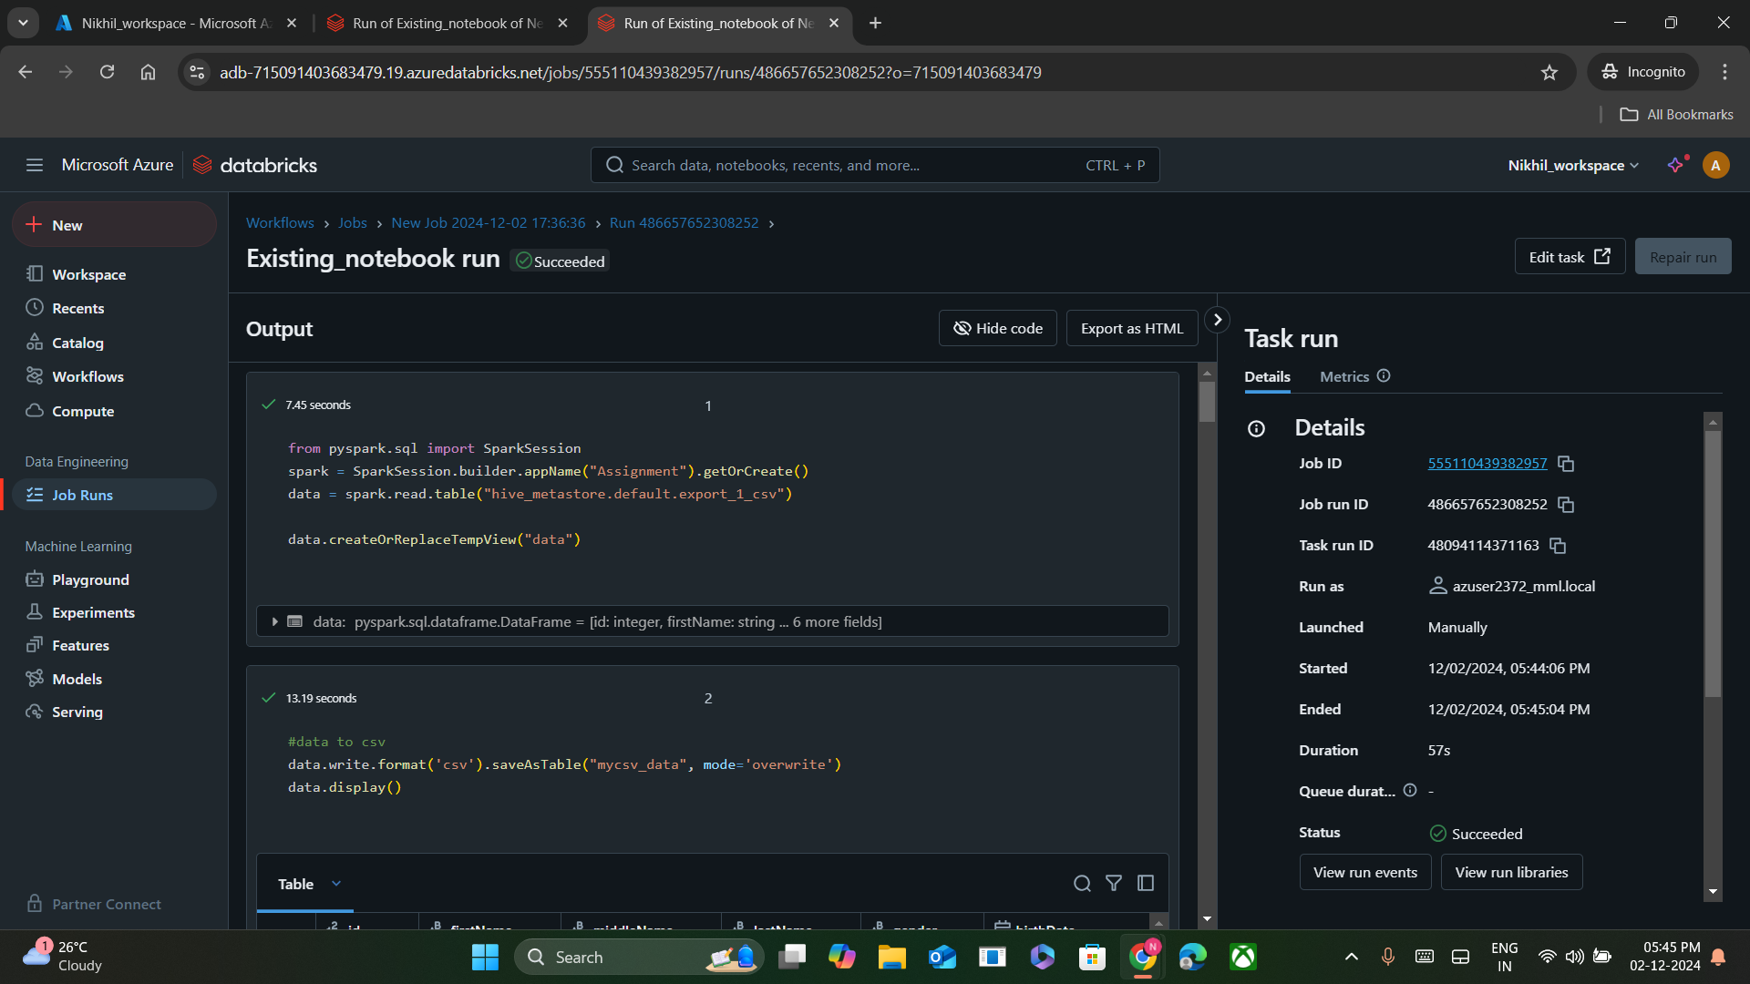

**Job Result:**

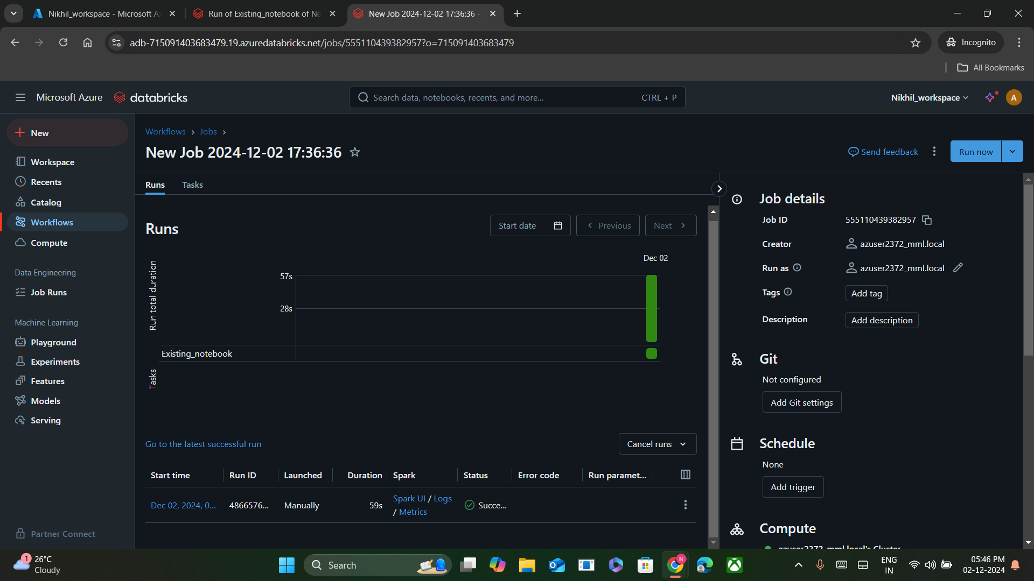

**Storage Creation in Data bricks:**

**Step 1:** Click on storage accounts in dashboard. Click on create and fill required details that are mentioned in image.

**Step 2:** After giving the details, click on the create+review button. And again click on create button for confirmation.

**Step 3:** After the successful storage creation. The storage account is displayed like this. Therefore, the data storage account is created successfully.

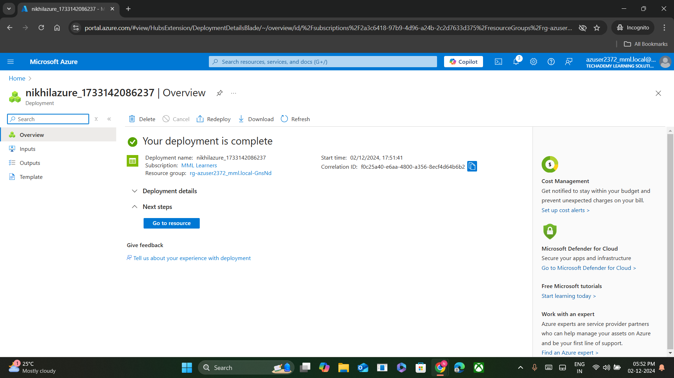

**Data lake Creation in data bricks:**

**Step 1:** Click on storage accounts in dashboard. And click on create button.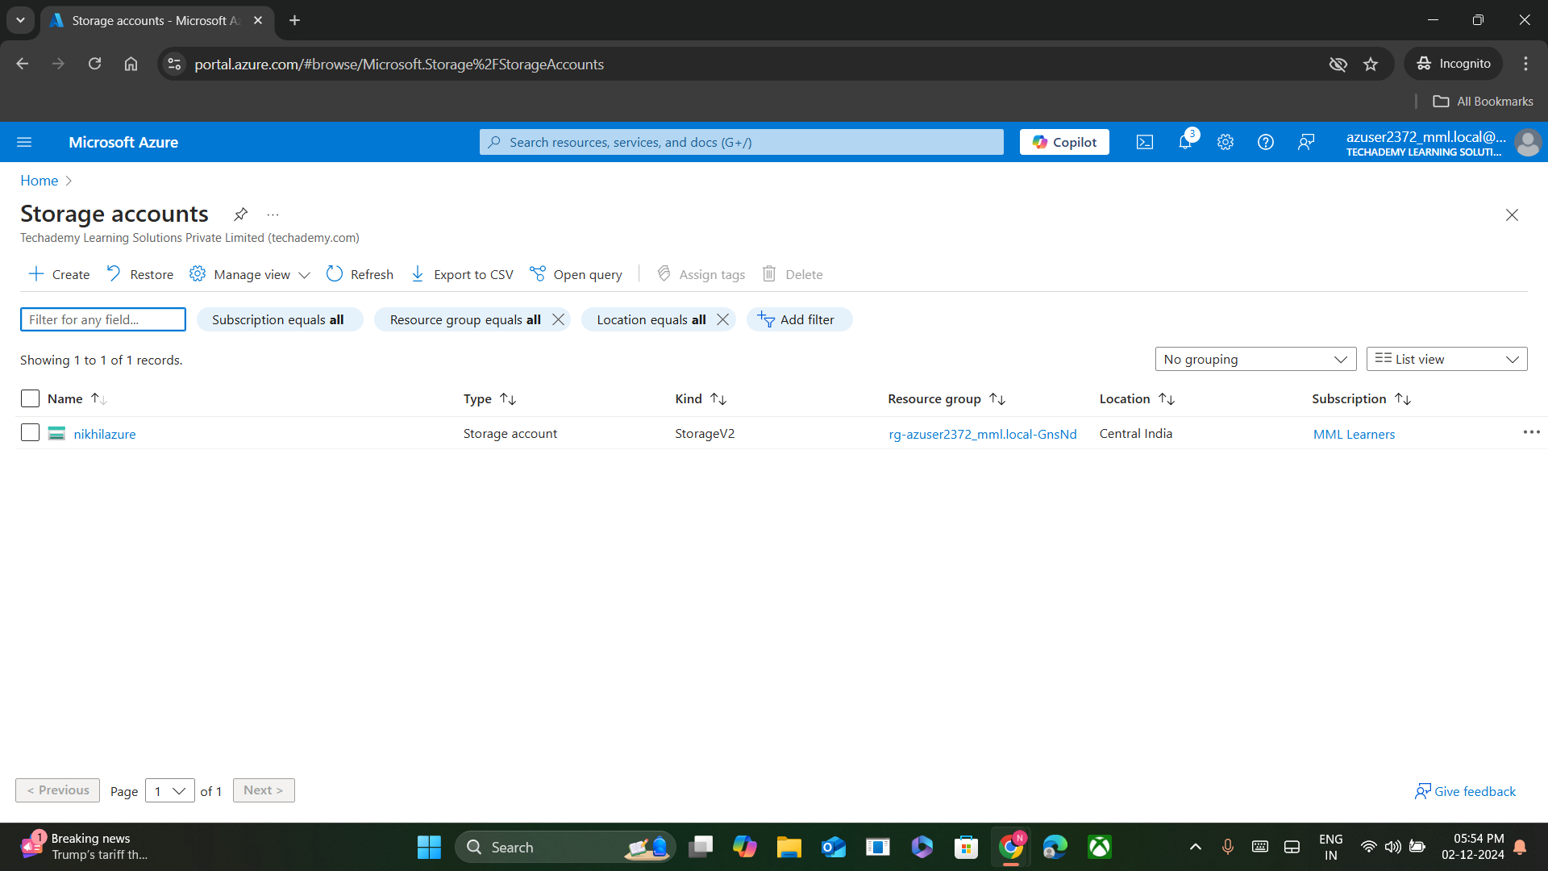

**Step 2:** Now provide appropriate details as shown in the image. And click on ‘Next’ button.

**Step 3:** Now enable the ‘hierarical namespace’ option by clicking on it’s box. And then, click on Review + create button.

**Step 4:** Confirm the account creation by clicking on the create button

Therefore, the data lake account is created successfully.

